Student worksheet

6.3 Boundaries between the tectonic plates can be convergent, divergent or transform

Pages 120–123 and 216

Plate boundaries

1 Summarise information about tectonic plate boundary movement in the following table.

|  |  |  |  |
| --- | --- | --- | --- |
|  | Transform | Convergent | Divergent |
| Direction of movement (use arrows) |  |  |  |
| Description of Movement |  |  |  |
| What types of tectonic plates are involved? |  |  |  |
| Effect of the movement, i.e. what does it result in? |  |  |  |

2 There are 3 types of convergent plate movement that depend on the types of tectonic plates involved. For each illustration in the table below, name the types of plates involved and describe what happens.

|  |  |  |
| --- | --- | --- |
| Diagram | Types of plates | Explanation: |
| L:\1. Publishing and Editorial\1. Product\Amazing Science\Amazing Science 9\3. Extras\9. Student worksheets\Artwork\4. Final jpgs\SW0511_01439-r.jpg |  |  |
| L:\1. Publishing and Editorial\1. Product\Amazing Science\Amazing Science 9\3. Extras\9. Student worksheets\Artwork\4. Final jpgs\SW0512_01439-r.jpg |  |  |
| L:\1. Publishing and Editorial\1. Product\Amazing Science\Amazing Science 9\3. Extras\9. Student worksheets\Artwork\4. Final jpgs\SW0513_01439-r.jpg |  |  |

Extend your understanding

Convection currents, which are located beneath the surface of the Earth, cause tectonic plate movement.

3 Using your knowledge of kinetic energy and density, explain how a convection current is created within the Earth.

4 On the diagram below, add arrows pointing left or right in the boxes, showing direction of plate movement.

.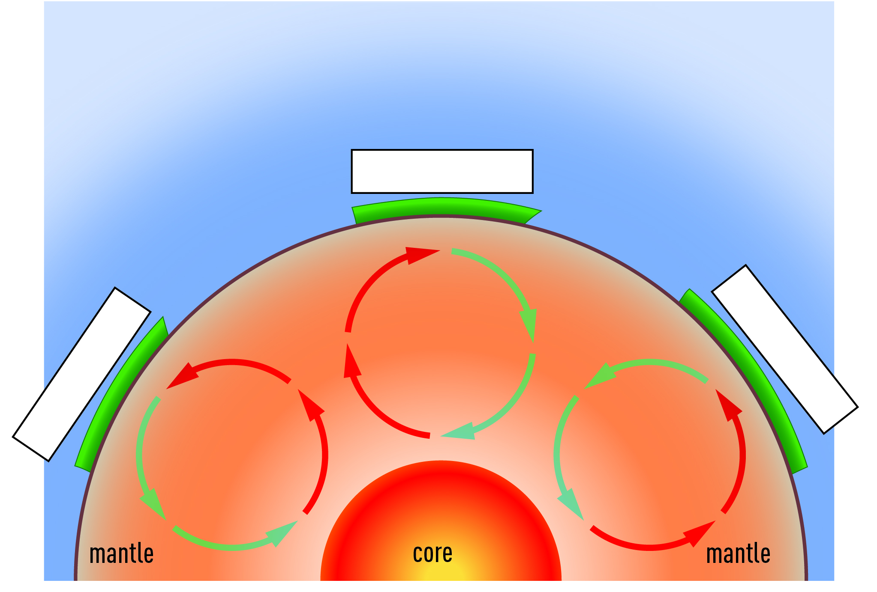

5 In which layer of the Earth are there convection currents?

6 Why are there convection currents within this layer?